

**Winter Break Week - Paid Leave Reporting**

Database: <https://hr.ku.edu>

Navigate to:

Time & Absence (Employee), My Team Time & Absence (Supervisor), or Campus Time & Absence (Time Reviewer)

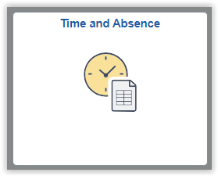 or 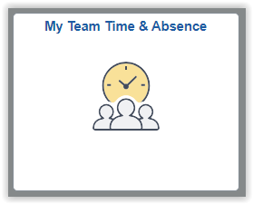 or 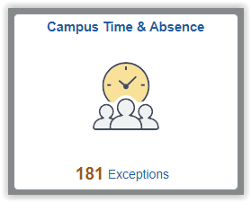

Paid leave (Winter Break Week) is being provided to eligible employees for **Friday, Dec. 26th to Wednesday, Dec. 31st**. Not all employees are eligible for Winter Break week; see FAQ section below for more information.

**The Winter Admin Break hours will not be loaded into the timesheet automatically.** The employee or the supervisor (for web clock employees) will need to add the Winter Admin Break hours manually in the timesheet.

The university acknowledges that certain units must maintain operations due to the performance of essential functions and cannot allow all employees to take time off simultaneously. As a result, an alternate period has been designated for these units. Employees can use the alternate dates of December 15th to December 24th to take a total of 4 days for the winter break.

This paid leave provides time for all eligible employees to rest and recharge, but hours and days will vary based on work schedules and operational needs. This is not a leave accrual benefit and will not be added to any type of leave balances. It is not allowed to be paid as additional compensation.

*Exempt (salaried) employees do not report any information in HR/Pay related to the Winter Break Week period.*

**Regular Hourly Clock Reporting Employees**

1. The supervisor or time reviewer will need to add the Winter Admin Break (**WTRBK**) hours to the timesheet for regular hourly clock reporting employees to be paid. Clock Reporters do not have access to modify their timesheet.
   1. Absences are not submitted to record the usage of the Winter Break Week.

***Example:***  
1b) A regular clock reporter taking their paid Winter Break Week **Friday** **Dec. 26th through Wednesday Dec**. **31st**. (This same process will be followed if taking the alternate week.)

* Do not remove the Holiday Credit (assuming eligibility is unchanged).
* Select the **WTRBK-Winter Admin Break** time reporting code and add the total hours under the Quantity column for each day. (Example below is M-F 8-hour work schedule.) Example is after hours are submitted.

Week 1:

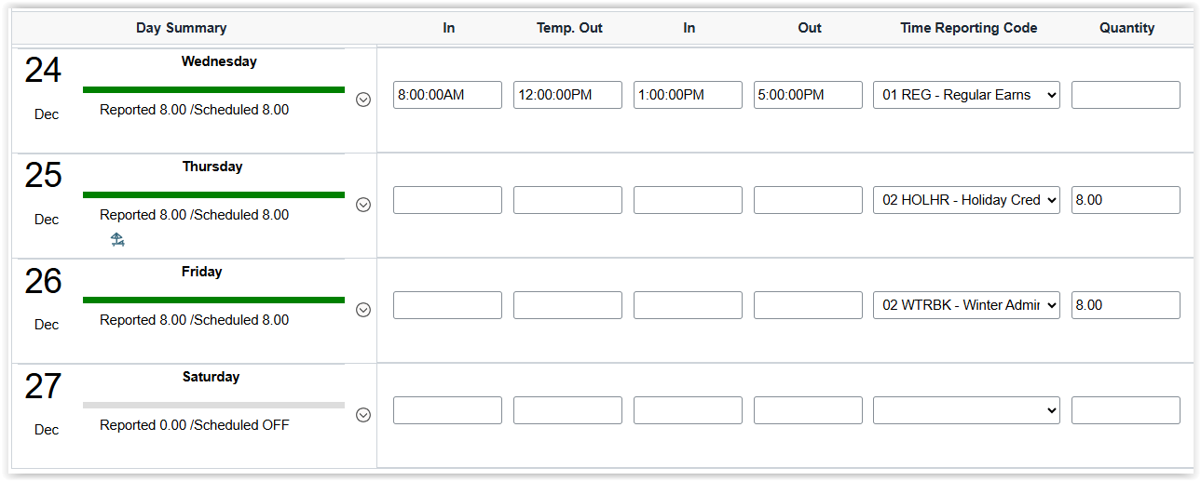



Week 2:

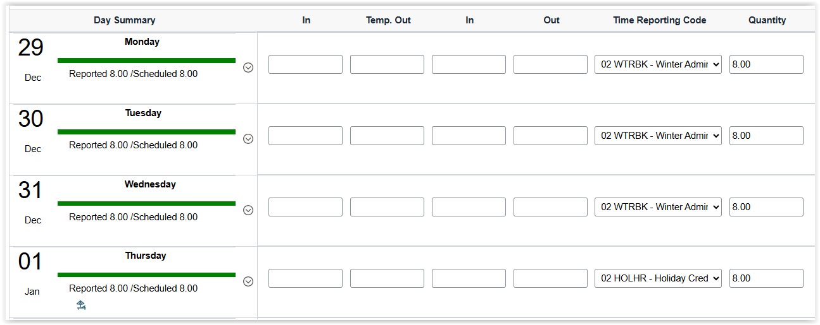



As usual, after submission of the timesheet and after the Time Admin process has been run, the supervisor or their delegate will be able to approve the payable time hours.

**Regular Hourly Timesheet Employees**

1. Regular hourly timesheet employees will need to add Winter Admin Break (**WTRBK**) hours to their timesheet to be paid. (Supervisors and time reviewers also have access to add this data.)
   1. Absences are not submitted to record the usage of the Winter Break Week period.

***Example:***  
2b) A regular full-time hourly timesheet employee taking their paid Winter Break Week **Friday Dec. 26th through Wednesday Dec. 31st**. (This same process will be followed if taking the alternate week.)

* Do not remove the Holiday Credit (assuming eligibility is unchanged).
* Add a row (+ left side) and select the **WTRBK-Winter Admin Break** Time Reporting Code.
* Enter the daily scheduled work hours (excluding the holiday) for the remainder of the Winter Break weekperiod. (Example is based on a M-F 8-hour work schedule.)

Week 1:

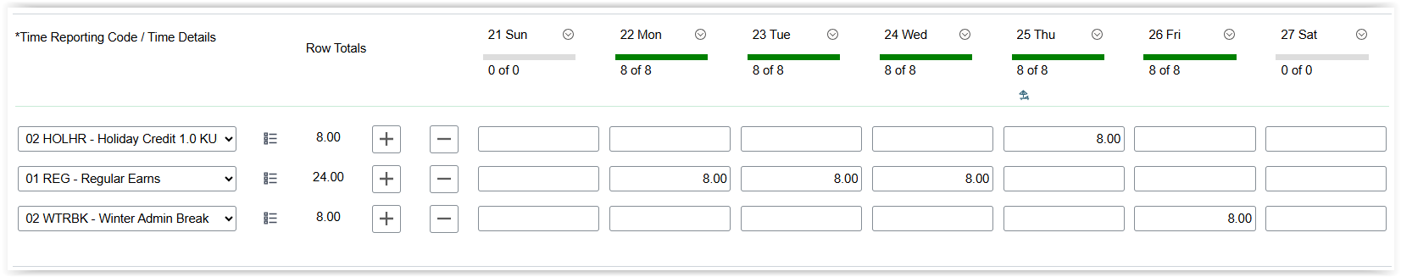



Week 2:

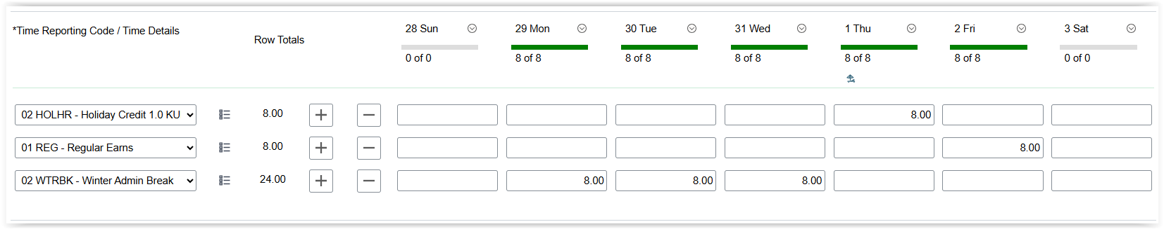



As usual, after submission of the timesheet and after the Time Admin process has been run, the supervisor or their delegate will be able to approve the payable time hours.

**REMINDERS/NOTES**

* Hourly employees using a timesheet must enter their time and/or absences at a minimum by the end of each work week.
* The payroll calculation for the period 12/7/25 to 12/20/25 will include the alternate Winter Break Week period.
* There is a firm deadline for approvals: **12 pm/Noon, Monday, Dec. 22nd**.
* If time or absences are approved after Noon on Monday, Dec. 22nd, there may be a minimum two-week delay in payment.
* The payroll calculation for the period: 12/21/25 to 1/3/26 includes the designated Winter Break Week period and approvals will be due at 5 pm, Monday, Jan. 5th.
* Temporary employees are not eligible for the Winter Break Week leave.

**QUESTIONS & ANSWERS**

**Are all employees eligible?**

No. Some employees are not eligible, and they are:

•          Employees on furlough

•          Employees on unpaid leave

•          Temporary students and staff

•          Affiliated corporation employees (not paid by KU)

**Should I remove the holiday?**

No, do not remove the Holiday Credit (assuming eligibility is unchanged). Be sure you add a row with each new time reporting code such as Winter Admin Break or Regular Earns.

**How should the Winter Break leave be documented in HR/Pay?**

Regular hourly employees or their supervisors will need to add a row in the HR/Pay timesheet for the time reporting code of WTRBK – Winter Admin Break and include the total scheduled hours per day to be paid correctly. (The supervisor must add the data for those regular hourly employees who use clock methods for reporting.)

Salaried employees will not take any action in the HR/Pay system to be paid.

**If an employee chooses to work instead of taking the winter paid leave, will they earn compensatory time?**

No. Allowing employees to choose compensatory time instead of time off would increase the liability cost. No compensatory time or additional pay are allowable for those who do not take the time. Supervisors should make every effort to allow eligible employees the time off.

**Can employees still take vacation or other paid leave to extend the Winter Break Week?**

Yes, in addition to the extra paid leave, we encourage employees to take vacation or other personal paid leave to refresh and reenergize with supervisory permission. Leaves are reported through the Manage Absences tile.

**The payroll period ends Dec. 20th, so how will this work for approvals due on Monday, Dec. 22nd?**

Employees are to enter all time and absences at the end of each work week.

*Supervisors will still need to approve all time and absences by Noon, Monday, Dec. 22nd.*

Employees whose time and absences are not entered by the end of the work week, and/or the supervisor does not approve by the Noon Monday, Dec. 22nd deadline, may have a minimum two-week delay in pay.

**KUEA Loans**

As KUEA will also have reduced hours, it will not be possible for the Payroll Office to request KUEA loans for late pay (due to no fault of the employee). It will be especially important for time and absences to be submitted at the end of each work week and approved by the deadlines. Questions:  [payroll@ku.edu](mailto:payroll@ku.edu).

Please contact Human Resources-HR/Pay at [hrpay@ku.edu](mailto:hrpay@ku.edu) or 785-864-0600 if you have any questions.