Web Clock Guide
Database: https://hr.ku.edu

Tile: Time and Absence>Report Time
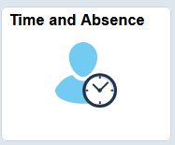
Temporary Hourly employees and Regular Premium Pay employees are assigned the Web Clock and are required to clock in and out to record work times. This is a condition of employment.
Employees are responsible for alerting their supervisor/designee if there are any inaccurate or missed times. All worked hours must be compensated and must be recorded in HR/Pay.
- If you hold multiple jobs, you will need to select the correct job from the drop down and select Apply before recording your punch.
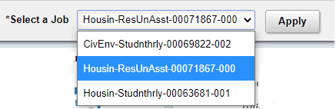
- Tile will display with the current date and time and the last action.
- Tile will show a button for submitting the current action.
- If the green button is displaying the correct punch type and this is regular work time you may click the button to clock. The display will change to reflect this as your Last action. (Students only have regular work time and only use In and Out Punch types.)
  - You are done.
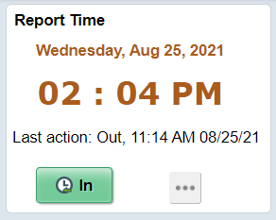
- If the Green button is the incorrect punch type or if you need a different time reporting code other than Regular (i.e. Call Back, Standby, Holiday Pay, etc.), click the 3 horizontal dots on the tile and select View Full Site.
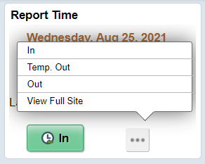
- Selecting the punch type from the 3 horizontal dots on the tile will submit the data; validate the time reporting code is correct before submitting.
- To change a time reporting code select View Full Site from the 3 horizontal dots on the Report Time tile.
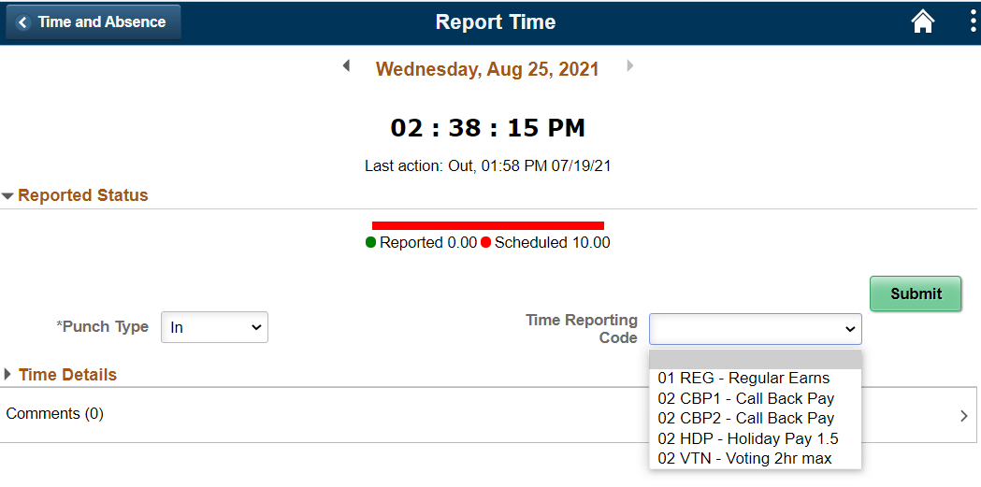
- If the time reporting code is correct, you may select the correct punch type from the 3 horizontal dots on the tile or you can change the time reporting code on the View Full Site.
  - In is for starting work.
  - Out is for leaving at the end of the workday.
  - Temp Out is used for meal break and other personal time off during the workday with the expectation of returning to finish the workday (regular employees use only)
- Click Submit button (if you are using the Full Site).
Other Reference Materials are located at humanresources.ku.edu/hrpay-resources.

Sign Out securely. Select the 3 vertical dots on right side of top banner and select Sign Out.

