Reported Time Audit
Database: https://hr.ku.edu
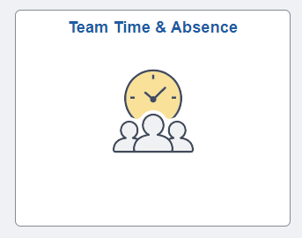
Left Menu Item: Reported Time Audit
Purpose: To allow Time Reviewers access to the time reporting audit table to assist their departmental customers. This will show when time has been added, modified and deleted. Page will also shows if the time was entered on a mobile device. Managers will also have access.
Notes: This is a vendor delivered page geared for core system team members not end users such as Time Reviewers or Managers. If a change is made to the data it may show changes for all clock times or totals for that day; validate by comparing the data.

- Search is only by Name and the full format is Lastname,FirstName Middle. You may search by just last name or last name and first name. Use the search magnifying glass and select name.
- Fill in Start and End Dates. (The broader the dates the longer the response time.)
- If you want to see the historical rows in addition to the current row – Expand all History rows to Yes.
- Select Get Rows.
- The changed value is indicated by a filled circle.
- Status: Current, History or Delete.
- Action: Add, Change or Delete.
- Audit User ID is the Employee ID of the person who made the change. You will need to use other pages to look up the name for the ID.
- Audit Date/Time is the time stamp for the data row.
- Mobile: To see if a mobile device was used, look at the tab &Time Reporting Elements under the Source column.
Examples:
