HR/Pay Top User Updates from 11/5/23 maintenance.

Employee – Personal Details- Self Service users will now select a + to add a different type for phone and email.
Employee and Manager/Supervisor
- Enter Time – Color and outline changes on menus and timesheet.
- Enter Time - Left side heading will show the short descriptions for the employee’s Department and Title, Position Number and Employee Record. (All users)
- Enter Time - Date heading is on the left side. (All users)
- Enter Time – Calendar icon allows selection of start date on the left side. (Elapsed–All users; Punch–Manger/Supervisor)
- Enter Time - View By dropdown allows view by week or pay period on the right side. (Elapsed–All users; Punch–Manger/Supervisor)
- Elapsed Timesheet Comments – Related Actions (blue circle) (All users)
Users will need to select Add/View Comments from the arrow on the related actions circle.
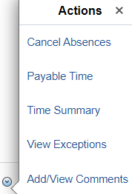
- Absence View Request – On the list of absences the duration shows below the date(s) on the right side. (All users.)
Please contact the HR/Pay Team hrpay@ku.edu or 785/864-0600 with any questions you may have about these changes.

