

How to Opt-Out of KU Alerts in HR/Pay

- Login to HR/Pay at https://hr.ku.edu.
- Select the Personal Details tile, then select the Emergency Text Message tile.
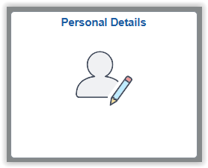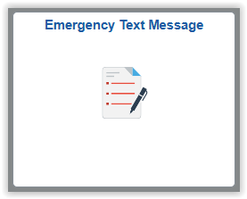
- The page shows whether you are currently subscribed to KU Alerts or not.
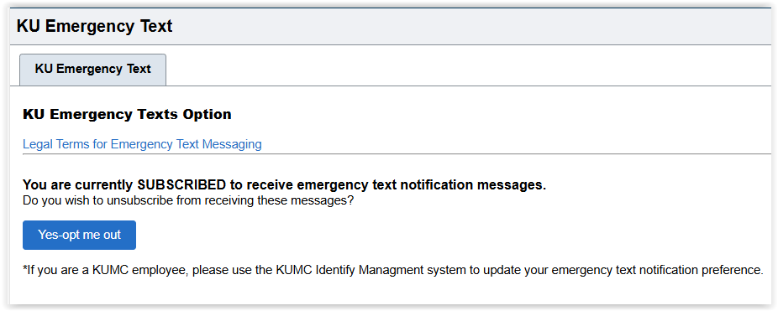

- If you are currently subscribed to receive emergency text notifications and no longer want to, select the “Yes-opt me out” button.
  - If you select the button, the page will change to reflect your current selection.
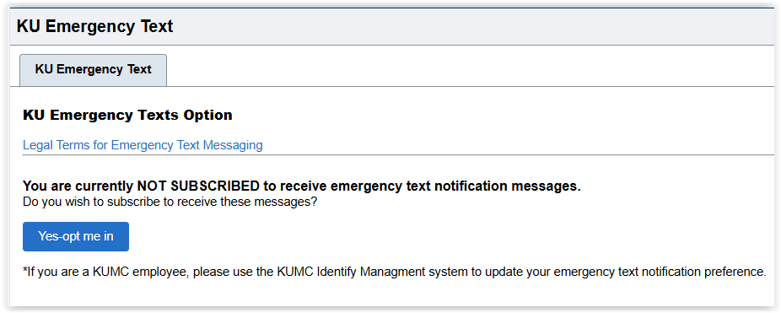
- If you are currently not subscribed and wish to be, select the “Yes-opt me in” button.
  - You must have a Mobile number in HR/Pay to receive KU Alert text messages.

