

How to Add a Cell Phone in HR/Pay

- Login to HR/Pay at https://hr.ku.edu.
- Select the Personal Details tile, then select the Contact Details tile.
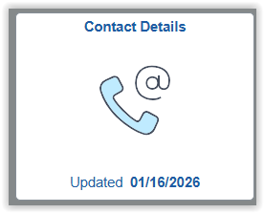
- To add a new phone number, click the “+” button.
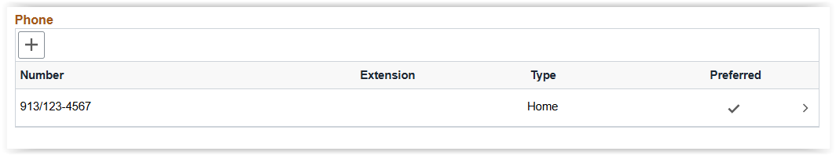
- A dialog box appears.
- Select the Type of “Mobile” in the drop-down option, then type in your cell phone number.
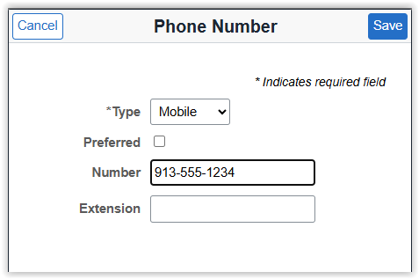
- Click Save.
- Note: Mobile phone numbers are automatically subscribed to KU Alerts text messaging service, unless you opt-out. If you have a mobile phone number and you do not want to receive KU Alerts, please opt-out using the Emergency Text Message tile in Personal Details.

