HR/Pay Funding Change Request Form

Primary Use:
The HR/Pay Funding Change Request form may be used for all funding changes being requested from departments. AMS or HR Transactions will be processing funding changes from this form. This form is housed in Perceptive Content. Due to the functionality of this form, processors will no longer need to email funding change approval grids to funding authority. Automatic notifications will be sent from the system to alert the PI, Budget Officer and any other applicable staff that the funding change has been processed.

Submitting a KU HR/Pay Funding Change Request Form

Before Starting the KU HR/Pay Funding Change Request Form
- Communication from the PI or department staff should initiate this process. Once it is known that a funding change is needed, the KU HR/Pay Funding Change Request Form should be completed.
- The department needs to provide the necessary information needed for a funding change:
  - Effective date
  - New funding chartfield strings with % of effort allocated, total effort should be 100%
- If a new pool is needed for the requested funding change, the Funding Set Up Request (FSR) form should be submitted.
  - Once notified of the Pool ID being set up, then you may proceed to next step.

Filling in the KU HR/Pay Funding Change Request Form
- Navigate to https://humanresources.ku.edu/hrpay-funding.
- The form should be completed as shown below:
  - When requested, AMS will complete forms when sponsored funds are involved
  - For 100% non-sponsored-funded requests, units/departments should complete/submit
- Workflow and Notifications section:
  - Click Yes or No per emboldened guidance. If Yes, select the appropriate AMS team.
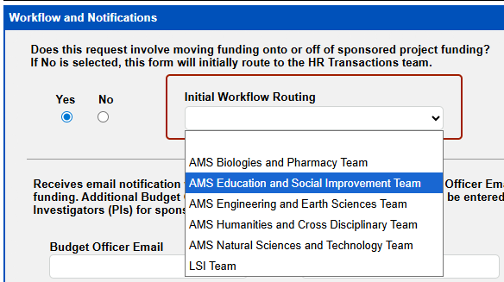
The form submitter and project PIs will be notified automatically via email. The relevant Budget Officer’s email address is required to be provided by the submitter. Two additional interested parties may be added, if needed. This will allow the system to send all pertinent notifications to them. 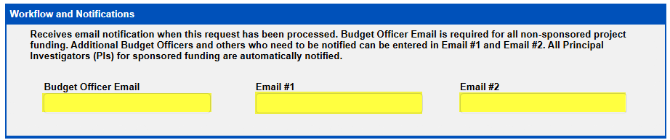
Funding Change section:
- Funding Change Type: Please select if this is a Position or Pool funding change. 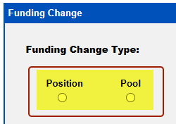
  - Pool funding changes require pools to be setup before completing this form. If a new pool ID is needed, please use the Funding Set Up Request (FSR) form.
- Funding Change Targets: Select either the Employee or Position, depending on how you want to look up the Employee’s information.
  - If you select Employee, then you can lookup by last name or ID:
    - Enter in the last name & click on the magnifying glass 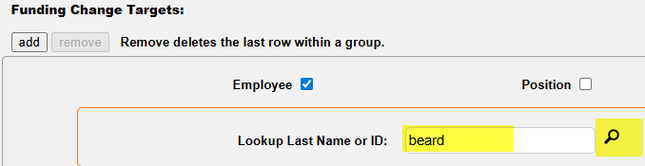
    - If there is more than one person with that name, it will bring up an Employee Lookup box so that you can select the correct employee. Higlight the appropriate name and click on OK. 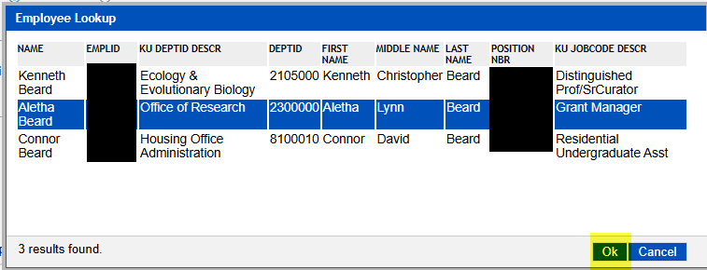
    - This will populate the employee info for the form. 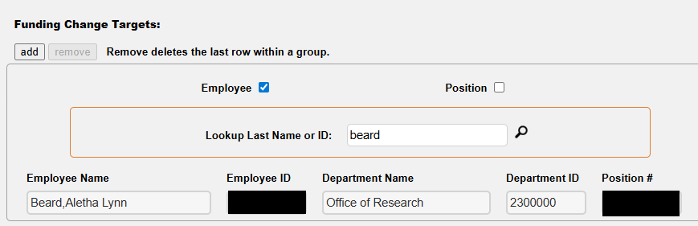
- Funding Change Detail: This section includes all of the details about the requested funding changes.
  - Add your effective date of the requested change. If any overrides are required for this funding change, click the appropriate box.
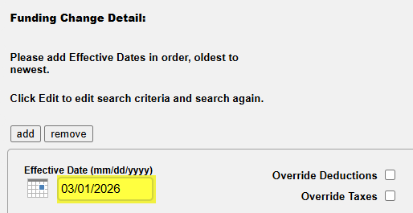
  - The next section is for comments tied to the effective date. Click Add button to open the comments section for info. 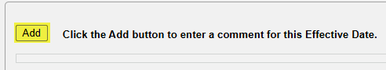
Only needed if there are multiple end dates or default funding was used. ` 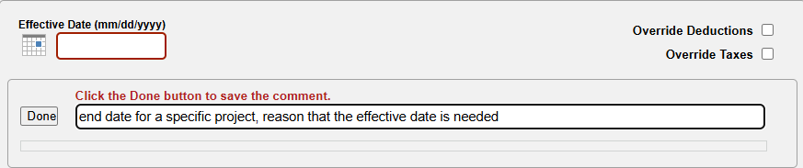
  - If you have multiple funding changes in the same pay period (PP), click the add button to add the next date. And repeat all above steps to add the effective date and comments.
  - If you need to remove an effective date, navigate back to the Funding Change Detail and click remove.
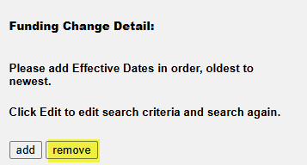
- Earnings Distribution: this section will include all new funding being requested. It should total 100% distribution.
  - Click the Add button for each funding line needed. 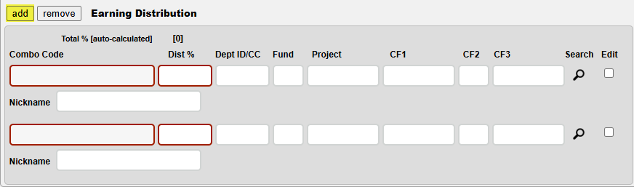
  - Click in the project field, type in your project number, then click on Search icon. If there are multiple combo codes associated with the project, select the correct line needed, then click OK. 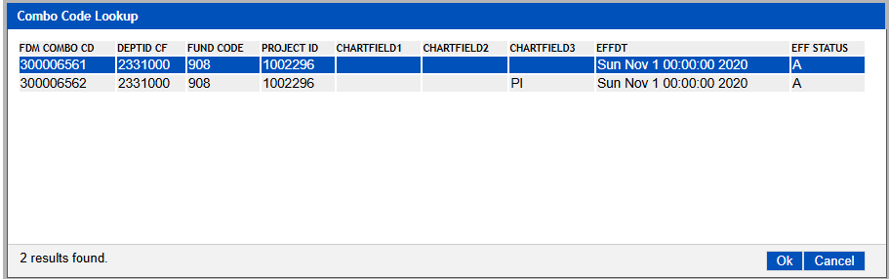
  - If keying non-project funding, type in the Dept ID/CC and Fund, then click on Search icon.
  - Put in the Distribution %
  - Add any Nicknames (project names) that will help the PI/stakeholder know what the funding is associated with.
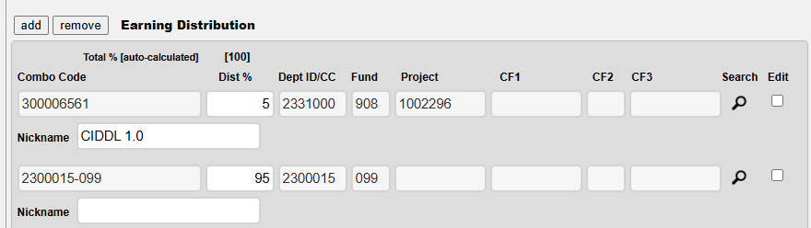
Comments section: Every form should have a Comment added to it with details about how the funding change was requested, by whom, and any other pertinent information. 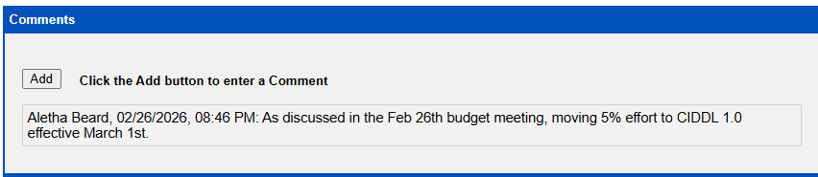

Click on the Submit button at the bottom of the form when all information is complete. 

