Empowering a community of excellence.

HR/Pay Funding Entry Training Guide
Table of Contents
Documentation 2
Access 2
Dates 2
Rules, Roles, and Responsibilities 2
SetID or Business Unit 3
Department 3
Funding Relationship Diagram 4
ChartField Values 5
1) DEPT ID 5
2) Fund Code 5
3) Project 6
4) Account 6
5) ChartField 1: 6
6) ChartField 2 6
7) ChartField 3 7
Combination Code Table 7
Position Pool Table 8
Department Budget Table USA (DBT) 9
Entry Update Example 10
Position Pool Table 11
Override the Dept. Budget Deductions and Dept. Budget Taxes 13
Pay Group and Proration and Effective Dates 15
Abbreviations Used in Funding 15
Addendum - HR/Pay Abbreviated Funding Entry Quick Sheet – Regular Position 16

This is a supplemental guide just for entering funding into HR/Pay. This document contains a review of key data points from basic HR/Pay navigation.
Documentation – for request or authorization for funding changes must be kept in the designated site which is on the My Community – KUL Sharepoint. There is also a “Shared Service Center” Checklist that may be used.
https://kansas.sharepoint.com/teams/ssc/project_funding_changes/SitePages/Home.aspx
Click on the correct month, then the correct folder, drag the email to your desktop, then drop it on the site. This allows the emails to be searchable. Instructions are on the site.

Access – Designated HR Transaction/HR Appointment/AMS (Award Management Services – Research) staff, Budget Office and Vice Chancellor for Research HR related staff will have access to update the Department Budget Table (DBT) and Position Pool Table. The HR Transaction/HR Appointment/AMS access is approved by the Human Resource Management (HRM) HR/Pay Director and if applicable Office of Research after training along with the Payroll Director. Most core set up tables are view only access outside the Budget, Payroll and HRM offices. Access may also be revoked by HRM. HRM will consult with Payroll and Research appropriate.

Dates – Funding for a payroll period may be keyed until the first payroll calculation process (use the Time and Absence approval deadline for determination). Please reference the HR/Pay Calendar on the Human Resource Management website: humanresources.drupal.ku.edu/hrpay-calendar

If the deadline date above has passed, the HR Transaction/Award Management Staff are not allowed to key the funding retroactively unless the position was vacant.

If payroll has been calculated for the payroll period being affected, the late funding change will be managed as an RFA (Retroactive Funding Change). RFA requests are processed by the submission of an ePAF for Position or PAF for Position Pool ID with all the required documentation. The RFA data entry will be done by the Payroll or HR Appointment Staff when they process the RFA. If necessary, the HR Transactions/HR Appointments/AMS should enter a new “current” effective dated row to prevent additional RFAs.

Rules, Roles, and Responsibilities

Funding for a payroll period may be keyed until the first payroll calculation process (use the Time and Absence approval deadline for determination).

HR Transaction/HR Appointment Staff and Award Management Services (AMS) are to
- follow all business processes and guidelines including deadline dates and documentation.
- be responsible to validate before keying, that
  - The correct tables are set up and are valid to use or, if not, to resolve before entering data. In some situations, data entry may not be saved due to system edits.
  - For Projects - this includes the funding entry is effective within the Project dates, budget monies for the type of employee expense and there are monies available.
  - Should not key a date in the Funding End Date field or any other field not covered in the materials.
  - Validate Effective date before saving.

If incorrect data entry or lack of validation causes incorrect funding and (1) RFAs or (2) Budget Transfers are needed to correct or (3) creates delays in the funding distribution of payroll, additional training may be required by HRM. Access may also be revoked by HRM. HRM will consult with Payroll as appropriate.

AMS Staff are to validate the funding request change meets the requirements defined and are acting with full authority on behalf of a Budget Officer, appropriate Principal Investigator (PI) or appropriate accounting staff to enter the funding change into HR/Pay timely and accurately and follow all business process rules.

Budget Office and the Office of Research Budgetary Staff (Future Items– Clean up and then Ongoing)
- Inactivate set up values (Combination Codes and Pool ID) when they code should not be used. This will require monitoring to have active employees removed from the funding before inactivation to not cause disruption of the Payroll funding distribution process. Partner with HRM for building process.
  - Research will need to keep Project Combination Code values active 90 days after the end of the Project to allow closing of expenditures.
  - Budget Office also includes maintenance of the DEPT ID ChartField.

Correction mode will not be given out to HR Transaction/AMS, Budget, or Research If correction mode is required to enter the data, then an ePAF will need to be submitted for Position or PAF for Position Pool ID. Correction mode is required when the new row being inserted is prior to a current row in effect. The system will not save the data and will indicate correction mode is required.

Effective dated rows that have been saved should not be deleted or typed over. If the row is incorrectly entered or has changed, the page should be called up again, a new row is to be added. The HR/Pay system will assign a new sequence row when multiple rows for the same date exist. This includes future dated rows.

Budget Officers are those who oversee and have responsibility for managing the university budget for an Area of Responsibility (ARSP), generally they are staff within a Dean or Vice Provost’s office. They have responsibility for new Departments, Dept/Cost Centers, KUEA Values, ChartField 1 and Pool IDs.

SetID or Business Unit are both UKANS for the Lawrence campus transactions.

Department
HRM Partner Tile>Core Table>Departments
A (HR) Department is defined as “the smallest organizational unit of the University recognized by the central administration which has: one or more positions, a budget, and sovereignty (meaning that the Department has its own mission, authority over its own budget, and authority over its own operations).”

Budget Officers will send in requests for new Departments via email addressing the definition requirements and must be approved by the HRM - HR/Pay Director (Pam Burkhead) and Budget Director (Mary Ann Richey). HRM -HR/Pay is the steward of the table and oversees the request.

This Department is not the funding source and is not a ChartField but rather it is who the employee is working for. This is also where HR/Pay tracks the “specialist” by department. Specialists are the Benefits contacts, Shared Service contacts, Department Representative and Budget Officer.

Sometimes known as the HR Department. View access is granted to this table.

Funding Relationship Diagram

Combination Codes are unique combinations of ChartFields

Linked together by the Department and Pool ID
Many Positions to One Department Budget Table -Pool ID
Linked together by the Department and Position
Linked together by the Department and Position for Regular positions.
One Position to One Department Budget Table-Position

ChartField Values
HRM Partner Tile>Funding>…
ChartFields are accounting values as noted below:

  - DEPT ID: An organizational unit, within a department, which is used for tracking and reporting expenses. DEPT IDs must be identified as payroll (will be added to HR/Pay) or non-payroll in financials. All departments must have at least one DEPT ID with payroll (because all Departments will have employees). DEPT IDs with payroll are the only organizational units in the financial system by which payroll costs are tracked, entered, and approved by the Budget Office. “Descr” field must match Financials naming convention. “Department” is “true HR” department. View access is granted to this table.
    - Sometimes known as a Cost Center.
    - The determination of whether a DEPT ID is payroll eligible or not resides with the Budget Officers of the funding area. In most cases, the Budget Officers will work with the Budget Office to request new DEPT IDs or to change the designation of a DEPT ID. Request for new or changed to status of DEPT IDs are requested using the Funding Set Up Request Form.
    - DEPT IDs that start with 15103XX and are assigned by the Payroll Office. They are used with Funds that begin with 8XX and are reimbursable with other state agencies (i.e., KUMC and KBOR)
    - DEPT IDs that start with 2301XXX are General Research Funds (GRF) and are allocated by Research and are used with fund 099.
    - DEPT IDs that start with 2302XXX are New Faculty General Research Funds (NFGRF) and are allocated by Research and are used with fund 099.
    - For funds 918 and 928 the DEPT ID that is allowed on the Combination Code with these Funds is Project specific.
    - Budget Officers must approve the request to add a Dept ID for use in HR/Pay. The Budget Officer or Shared Service Center representative may initiate the request. https://inowformsprivate.ku.edu/fs?form=Funding%20Set%20Up%20Request%20Form

  - Fund Code: Identifies the source of money allocated by budget or earned by revenue-generating occurrences for the purpose of carrying on specific activities or attaining certain objectives in accordance with special regulations, restrictions, or limitations. Entry is by HR/Pay only after approval by the Comptroller’s office. View access is granted to this table.
    - Fund 709 is only for the federal part of the work-study funding for student employees.
    - Funds 717 and 718 are used for Projects associated with the UKANS Financial Business Unit
      - Require a Project to be used as noted on the Fund Table as the check is on the KU Project Fund field.
    - Fund 725 is only for KUEA (KU Endowment) reimbursable and requires ChartField 3 to be used as noted on the Fund Table-KU Reimbursable.
    - Funds that begin with 8XX are reimbursable to other state agencies KUMC-KU Medical Center and KBOR–Kansas Board of Regents.
      - This fund requires the ChartField 3 to be used as noted on Fund Table as the check is the on KU Reimbursable field.
      - The DEPT ID associated with the fund must begin with 15103XX and is assigned by the Payroll Office.
      - Payroll must be notified prior to keying any impacts to KUMC funding whether new funding or modification of existing funding source. This is part of the business agreement with KUMC in allowing us to charge directly.
    - Funds that begin with 9XX are associated with the Vice Chancellor for Research monies,
      - Some of the 9XX funds require a Project to be used as noted on the Fund Table when the check is on KU Project Fund field.
      - Funds 918 and 928 are not allowed to have ChartField 2 (CS) on the same combination code.
      - Funds 918 and 928, the DEPT ID that is allowed on the Combination Code with these Funds is Project specific If the KU Cost Share field on the Fund Table is checked on, this allows the fund to provide monies for In-Kind cost share expenditures.
      - 950 and 890 do not have direct payroll charges and are not set up in HR/Pay.

  - Project: Value assigned to sponsored projects and updated twice a day by a system process in HR/Pay from data in Financials. Original data source is via Financials entry by Research staff. View access is granted to this table.
    - Funding should not be keyed outside the project end dates without the approval of Research staff.
    - Funding should not be keyed if there is not a budget for the type of salary expenditure.
    - KU Cost Share – if checked allows this fund to provide monies for cost share expenditures toward the Cost Share part of the Project Budget
    - If authorized to create Cost Share combination codes: User must validate that the start date of the Project and the effective date of the Project Status both match on the first row, in addition to having the flag checked on for KU Cost Share. (Research)
    - If a Project does not exist in HR/Pay, and you believe it is a valid Project, contact Research payroll audit section.

  - Account: This is also known as the object code as its purpose is for tracking the type of expense i.e., regular earnings, holiday pay, or social security, health insurance.

The HR/Pay system will default 99999 in this field on the Combination Code Table. For most payroll transactions, the account on the combination code is 99999. The 9’s are replaced by the actual account during the payroll funding distribution process. This reduces the need for entering in a combination code for each earnings, taxes, or deductions. 9’s is the default that is replaced by the delivered process based on set up tables. Table is maintained by HR/Pay. View access is granted to this table.
    - If there is need to fund by one of the individual account values, please consult with the HR/Pay Team or Payroll if you are planning to do this. This should be extremely rare.
    - A list of all expenditure Account codes is located on the Procurement Services website. procurement.ku.edu/expenditure-account-codes
    - Values changed 11/2018 due to FITC implementation.

  - ChartField 1: Budget Officer (Dean’s, VP, or VC) designated use field as an additional way for tracking expenditures. ChartField 1 is an optional use ChartField.
    - CF1 starts within the Financials Systems by being entered into FITC (Financials in the Cloud) and Concur by a manual process. HR/Pay receives the data via interface from OAC. Allow up to 3 days for the CF1’s to be in OAC (Oracle Analytics Cloud service). Once the value is in OAC then it should be available in HR/Pay the following day. The date for all CF1 values in HR/Pay will be effective 5/20/18.
    - CF1 is not collected in PBCS (Planning and Budgeting Cloud System) Planning (BCP) or PPM (Projects Planning Module-Grants & Sponsored Projects) or in eCRT (effort reporting) or in Allocation of F & A (Facilities and Administration). PBCS Planning and Projects do not consume the CF1 in any of their accounting or allocations.
    - CF1 may be used on all funding sources and will reflect in the Gross and Fringe, FITC Budget Journals, PBCS Management and Payroll Journals in Financials.
    - Link to the form for requesting CF1 values: https://kansas.sharepoint.com/teams/fsrc/_layouts/download.aspx?SourceUrl=https://kansas.sharepoint.com/teams/fsrc/Forms/Add%20Remove%20CF1.xlsm

  - ChartField 2: Only value in this table is CS to denote In-Kind Cost Sharing on a combination code/funding source. This is used when interfacing to Financials and posting to the Project Cost Share budget. Requires the use of a Project. View access is granted to this table.
    - Funds 918 and 928 are not allowed to have ChartField2 (CS) on the same combination code.
    - For detailed information about Cost Share, please review the Office of Research materials.

  - ChartField 3: Value assigned for reimbursable funding and is used as an override to have funding post to the Key Personnel Budget Category for Projects only. Entry into this table is by the Budget Office for KUEA (KU Endowment) or by Payroll for KUMC (KU Medical Center) and KBOR (Kansas Board of Regents.) View access is granted to this table.
    - Required to be used for reimbursable funding with KUEA which is also noted by fund 725.
      - The format of the KUEA number is five numbers followed by an X. The five numbers represent the KUEA organization value.
      - The determination of whether a new KUEA source is payroll eligible or desired resides with the Budget Officers of the funding area. In most cases, the Budget Officers will work with the Budget Office to request the new value to be set up.
    - Required to be used for KUMC and KBOR reimbursable funding which both are denoted by funds beginning with 8XX.
      - KUMC and KBOR reimbursable numbers are only assigned by the Payroll Office
    - “PI” is the value required to be used in this field when the expenditure is to post to the Project’s Key Personnel Budget. (This is used to override existing Account processing.)
For detailed information about the use of PI and Key Personnel, please review the Office of Research materials.

Combination Code Table
HRM Partner Tile>Funding>Combination Code Table
Combination Code is a value representing a combination of ChartFields used for funding payroll expenditures. There is only one combination code assigned to a unique set of ChartFields. This combination code is entered into the Department Budget Tables (DBT) to correctly fund a Position or Pool ID.

Combination codes are routinely established by the campus budgetary offices – a) Budget Office for non–project monies including KUEA; b) Research for Project and other Research monies (fund 9XX); c) Payroll – Reimbursable Regents or d) HR/Pay Budgetary loads. View access is granted to this table.

Request for new Combination Codes is processed using the Funding Setup Request Form for Budget and Research. https://inowformsprivate.ku.edu/fs?form=Funding%20Set%20Up%20Request%20Form

- Notes about Combination Codes:

    - As of November 2018, codes created will just be a next system assigned number, we started with 3’s. Combination codes created prior to November 2018 will remain as is.
    - Cost sharing or matching may be described as a portion of project or program costs not borne by the funding agency. Cost sharing is typically in the form of an actual cash expenditure of funds.
      - For KU we have a separate payroll posting to the Project (PPM) to track the cost share as it is included in the funding of the employee via Position/Pool ID via the DBT.
      - As of the FITC implementation, Financials assigns a unique/separate Project Number for the Cost Share. Prior to FITC implementation, the Cost Share Project was the same number as the Project with the actual funding. Cost Share projects were converted to a unique Project chart field as part of the FITC implementation.
      - We cannot cost share on KUEA funding for a Project Key Personnel (PI) as we are sharing the ChartField 3 for both purposes, so it causes a conflict.

  - Funds that being with 8XX are reimbursable from other state agencies (i.e., KUMC and KBOR) and the DEPT ID (Cost Center) must begin with 15103XX. Established by the Payroll Office.

Position Pool Table
HRM Partner Table>Funding>Position Pool Table
The Position Pool Table is a set up table which provides validation and a description for the Department Budget Table (DBT) and displays on Position- Specific Information for Positions funded by like funding sources that do not need to be individually tracked and is an alternative to funding by a Position at KU.

Position Pools are used only for all Temporary Positions. (All Regular Positions are now all Position Funded.) (1/1/17)

HR Transactions, HR Appointments and Award Management Services (AMS) personnel with funding update will have access to update/display (insert new rows). View access to this table for those without update access. New Pool IDs will be established by a) Budget, b) Vice Chancellor for Research or 3) HR/Pay Budgetary loads.

Budget Officers have authority over non-research Pool IDs as they may use to track expenditures and impact tracking of internal budgets. HR/AMS should not inactive or request additional Pool IDs or changes without the authorization of the Budget Officers for non-Research monies.

Non-Research funded Pool IDs funding may be modified and is encouraged to reuse instead of creating new if the pool is no longer being used or no longer has valid funding. The Funding Setup Request Form is used to request new Pool IDs.

- A (HR) Department is assigned along with the Pool ID as key values need to be unique in the DBT.
- A Pool ID is required to fund temporary positions. This is required for postings to the budget system.
- Regular positions are not to be funded by a Position Pool *( as of 1/17)
- Pools ID may be inactivated once the funding is over.
- Pools ID are reusable once it is clear all expenditures have been finalized.
- Correction mode will need to be keyed by HR Appointment or Payroll.
- Effective Dated Rows are never to be deleted once saved.
- Work-Study will start with a W for the Pool ID value (exclusive)
- Pool values are important for interfacing to other systems
GXX –Graduate Assistant (GA)
SXX = Student Hourly (always Temporary Positions)
RXX = Graduate Research Assistants (GRA) (always Temporary Positions)
May also be used for other salaried students as determined by the Budget Office.
TXX = Graduate Teaching Assistants (GTA) (always Temporary Positions)
May also be used for other salaried students as determined by the Budget Office.
UXX = Unclassified includes all Faculty and Staff other than Lecturers (Temporary Positions)
CXX = USS (Temporary) C Pools are being phased out.
WXX = Work -Study (Exclusive) Used for all Students funded by Work-Study (always Temporary Positions)
LXX – Faculty (Temporary and includes temporary Lecturers)
0XX to 5XX= Research 9XX funding only (Temporary Positions)
If any pool has a combination of Research funds 9XX and any other funds, then a letter value for the Pool must be used. If funded 100% by sponsored project generally a #XX Pool will be used.

Department Budget Table USA (DBT)
HRM Partner Tile>Funding>Department Budget Table USA
- The Department Budget Table (DBT) is a set up table which provides funding for Positions or Pool ID.
This table has an effective date, fiscal year, combination codes and percent distribution entered for each (HR) Department and a Position or a (HR) Department and a Pool ID combination.
  - New DBTs are established by Budget, Research, HRM-HR/Appointment or HR/Pay Budgetary loads.
  - HR Transactions/HR Appointments/Award Management Services (AMS) personnel with funding update will have access to update/display (insert new rows).
  - KU only funds payroll expenditures by (HR) Department at either the Position or Pool ID level.
    - All Temporary positions are funded by the Pool ID level.
    - All Regular positions are funded at the Position level.
  - We do not fund at the Appointment, Department, and Job Code or by Employee ID.
  - Set ID = UKANS (always)
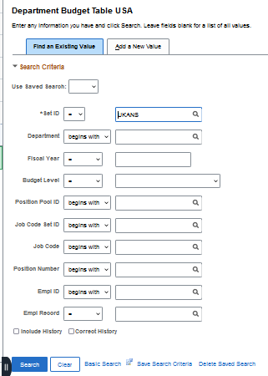

  - New Pool IDs will be established by a) Budget, b) Research or 3) HR/Pay Budgetary loads.
  - DBT has effective sequence; the highest sequence for an effective date in place at the time of distribution will be used.
  - Rows are not to be deleted that have already been saved – this includes future.
  - Correction mode will need to be keyed by HR Appointment or Payroll. An ePAF or PAF will be required. A new row may be added, and the system will assign the next sequence without the need for correction mode.
  - RFA (Retroactive Funding Changes – when the funding is changing on a previously confirmed paycheck) will be keyed by Payroll.
  - Entry Key Points
  - The establishment (keying) of new DBT will be by Budget, Research or HR Appointment or as part of the annual budgetary loads.
  - If a Position is changing departments and the funding is by Position, the prior department’s DBT is to be inactivated as of the last day the position is in the prior department and the new one is established the first day the position is in the new department.
    - Inactivation entries may be made by the HR Transactions/HR Appointments/AMS staff using the effective date that is the last day the position is on the prior department; inactivating at a later date will cause errors in the payroll calculation reports.
      - Position A is changing Departments from 1520000 to 1525000 on 09/25/18. The inactivation will be effective 9/24/18.
  - The HR/Pay distribution process looks for Position funding first. If position funding is not active or does not exist, the process will go to Position data to look for a Pool ID and use its active funding.
  - If funding does not exist or is inactive and there is a paycheck being funded by the Position or Pool ID as part of the calculation stream, the funding process will not be complete and will prevent the campus payroll from being completed.
  - Always validate for the correct “current” Fiscal Year and Department when viewing or entering funding.
    - No one is to enter funding distribution in a prior or future Fiscal Year.
  - Annually a HRIS-L notice will be sent that informs users that the system has been officially changed to a new Fiscal Year.
    - After the notice has been sent out, all prior fiscal year funding must be submitted by an ePAF or PAF and will be keyed by HR Appointment or Payroll into the current (new) year tables.
      - The delivered process may no longer recognize the prior year when distributing and Payroll may need to do additional work to make the funding work.
  - The system will validate the Position is in a matching Department along with the DBT as of the effective date of the row being inserted.

Entry Update Example
- In this example the Position Pool Funding for Department 1520000 – Pool ID S01 is changing from 003 to 099 as of 6/5/16. As the description includes the funding for ease of users searching on descriptions, we want to update the Position Pool ID description. This action does not change the actual funding. This is just changing the label. The actual funding is only changed in the DBT.

Position Pool Table
HRM Partner Tile>Funding>Position Pool Table
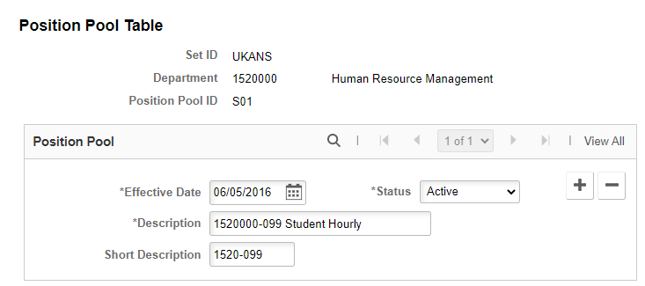

    - To insert a new row, select the button.
    - The current date will populate in the Effective Date field, please type the correct effective date or select from the calendar. (Example entry 6/5/16)
    - Generally, the ChartFields or some other helpful identifier are entered in the Description. (Example entry 1520000-099 Student Hourly)
        - Updated the Short Description (optional)
Save
Department Budget Table
To continue with our example, the next step is to change the funding for the Position Pool ID. Rows are not inserted into the DBT to update displays only. Only update the current Fiscal Year.

EXAMPLE

To insert a new effective dated row, select the button.
The current date will populate in the Effective Date field. Please type the correct effective date or select from the calendar icon if it is not today. Multiple tabs are displayed under the Earnings Distribution section.
    - Combination Code and the Combination Code Description are the main tabs used.
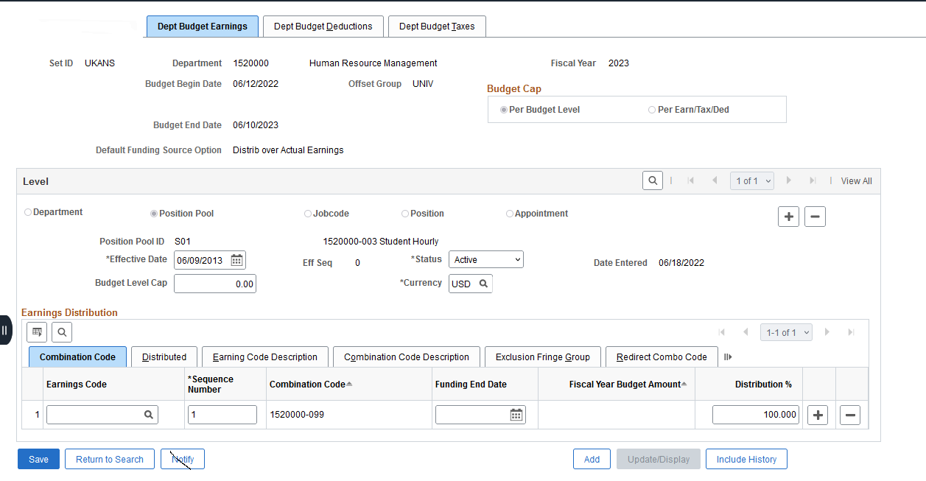
Key Items:
    - Sequence Number must always be 1.
Under the Combination Code tab, the sequence number displays. Each row must always be 1.
    - Funding End Date and Fiscal Year Budget Amount are also displayed and are to be left blank at all times. This is critical to funding distribution.

    - Distribution must always equal 100%
The Distribution % may have multiple rows but must always add to 100% or may only have one row that is 100%.
When a new row is inserted, the process carries forward all existing rows. To change our combination code from 099 to 700 funding
    - Delete the row(s) carried forward in the earnings distribution (this new carry forward row has not been saved yet) or select a new combination code to replace it. This is an individual preference.
    - If deleting the row under the earnings user must reenter the 1 in the sequence number field. In some cases, the combination codes stay the same and it is just a Distribution % so user would likely just change the % versus a row deletion.

    - To select a new Combination Code user must select the tab Combination Code Description
    - Click on the hyperlink ChartField Details
    - Then select the Search Options>Combination Codes>Search
    - Select value,
    - Validate ChartField Detail,
    - OK and then system returns you back to the DBT page.

This option above allows searching by the individual ChartFields, but users must use the Search button in order to have the values displayed. This will then only populate the individual ChartFields on the ChartField Details page

Users may need to add additional distribution rows. In this example we just have one row of funding.
    - Users should then go back to the Combination Code tab to validate or revalidate the % distribution. If a user deleted the earnings row previously (not saved yet), the user would need to type in the 100% Distribution % on the Combination Code tab (to match our example.)
    - The system will allow the use of any active combination code; it does not edit for departmental use.
    - It is okay to type in the % distribution before selecting the combination code.
    - Users must validate the following:
      - (HR) Department
      - Fiscal Year (HRIS-L will notify you when to change years, only enter in current year)
      - Position Pool ID or Position (in this case Position Pool ID) level of funding.
      - Position Pool ID or Position value
      - Effective Date,
      - Status (likely Active most Inactive status will be keyed by Research, Budget or HRM)
      - Combination Code(s) and
      - Distribution% (s) (sum to 100%)
Before selecting Save

  - Generally, this will update the Dept. Budget Deductions and Dept. Budget Taxes upon saving unless the Override is selected on these tabs.
  - Never correct or type over a saved effective dated row without calling the DBT back up again from the search box. Failure to call the page back up to correct data entry will not kick off the appropriate code in the system for the DBT to work.

Override the Dept. Budget Deductions and Dept. Budget Taxes
Overriding the Deduction and Taxes is done when the Earnings, Deductions and Taxes are not to be the same identical funding source and %.
This must be used on every work-study Position Pool ID as work-study does not pay fringe costs. Most if not all Pools will be set up by Research or Budget staff or during the annual budget load process.
The Override process may be used in cases for example where a Project does not pay fringe or on monies in which the fringe cost is charged to another funding source.
The Override process is only to be used when the funding is not exactly the same for Earnings, Deductions and Taxes.
Override box displays under the Dept Budget Deductions and the Dept Budget Taxes tabs.
How the System is Designed to Work -
- When the Override box is not checked on, which is the default, the system will use the Earnings funding for all Earnings, Deductions and Taxes (regardless of what is displayed on the page). This is the most common way KU funds.
- When the Override box is checked on the system will use the the Funding entered on each of the tabs Earning, Deductions and Taxes. Combination Codes and % must be included on each tab equalling 100% for each tab. This is required for all Work Study Position Pool IDs and may be used in other special circumstances. The funding is not a display of Earnings but a data entered row for Deductions and Taxes.
How is the box checked on or off?
  - Code logic is called when the Save is done based on the data entry (exact entry steps must be followed).
  - Do not save until all data has been entered in the Earnings, Deductions and Taxes pages.
  - If the user saves in between pages/tabs the code will not work.

- To activate the Override coding
  - Add a new Effective Dated Row (must be an Add +)
  - Delete all distribution rows in Earnings, Deductions and Taxes.
  - Enter in Earnings
    - Sequence Number 1, Combination Code(s), and Distribution % changes as needed.
    - (Do not save).
  - Enter in Deductions
    - Enter in Sequence Number 1, Combination Code(s), and Distribution % changes as needed.
    - (Do not save)
  - Enter in Taxes
    - Enter in Sequence Number 1, Combination Code(s), and Distribution % changes as needed.
    - (Do not save)
  - Proof your entry then Save
    - Upon saving, the code will know there are rows added to Deductions and Taxes and it will use the Combination Codes and Distribution %( s) for Deductions and Taxes and checks on the Override Box.

- To Inactivate the Override coding
  - Add a new Effective Dated Row (must be an Add +)
  - Delete all distribution rows in Earnings, Deductions and Taxes.
  - Enter in Earnings
    - Sequence Number 1, Combination Code and Distribution % changes as needed.
  - Proof your entry and deletion of rows and then Save.
  - Upon saving, the code will know there are no rows added to Deductions and Taxes and will use the Earnings Combination Code and Distribution funding for Earnings, Deductions and Taxes and the Override box will not be checked.
- After saving be sure and validate that the Override checkbox is checked on or off as expected. If not, user must call up the DBT again and insert a new row and do again. You cannot type over and have the code work. It only works on the first Save.
- Never correct or type over a saved effective dated row after a save without calling the DBT back up again. Failure to call the page back up to correct data entry will not kick off the appropriate code in the system for the DBT to work.

Pay Group and Proration and Effective Dates

Salaried Pay Groups
CUX - University Support/Unclassified Professional Staff & FY (Fiscal Year) Faculty/Academic Staff – 10 day Prorate
LCT – AY (Academic Year) Faculty/Academic Staff with ongoing commitment-Prepaid Benefits – 14 day Prorate
LFC - AY (Academic Year) Faculty/Academic Staff- 14 day Prorate
LTX –Less than 12-month Staff with ongoing commitment-Prepaid Benefits – 10 day Prorate
SRX - Student (generally Graduate Assistants) – 10 day Prorate
UPDATE 5/2024 Graduate Research Assistants were moved to STX from SRX.
STX - Student (generally Graduate Teaching Assistants & Graduate Research Assistants) – 14 day Prorate
UPDATE 5/2024 Graduate Research Assistants were moved to this paygroup.
(GTA do have set fall and spring semester and summer session dates, GRAs do not.)
Hourly Pay Groups
CUN - University Support/Unclassified Professional Staff & FY (Fiscal Year) Faculty/Academic Staff
STN – Student Hourly

Effective Dates
HRM Calendar – Deadlines humanresources.ku.edu/hrpay-calendar
Payroll Calendar – Contains Pay Periods and Dates payroll.ku.edu/ (Calendars)

Abbreviations Used in Funding

AMS – Award Management Services unit of the Office of Research
AY- Academic Year – used for those who have appointments that fall between 8/18/XX and 05/16/XX (5/15 leap year) (272 calendar days) including semester only appointments 08/18/XX-12/31XX (136 calendar days) or 01/01/XX-05/16/XX (5/15 leap year) (136 calendar year days). This is generally used for Faculty without administrative appointments such as Dean, Vice Provost, and Vice Chancellor etc.
Budget- Budget Office
Combo Code – Combination Code (Combination Codes represent a unique set of ChartFields.)
DBT - Department Budget Table where funding is keyed.
ePAF – Image Now Workflow Form that routes to HR Appointment Team or Payroll for entry into the HR/Pay System
FY - Fiscal Year and for HR/Pay the dates are determined by the paycheck dates that fall between 7/1/XX and 6/30/XX
HR/HRM - Human Resources/Human Resource Management Department under the Operations Division
HR/Pay – KU’s Human Resource and Payroll system (Oracle PeopleSoft Human Capital Management System)
785/864-0600 hrpay@ku.edu
HR/Pay Team –unit in HRM, Functional System Team for the Human Resource Payroll System
PAF – Image Now Workflow Form that routes to HR Appointment Team or Payroll for entry into the HR/Pay System
Research - Office of Research (Vice Chancellor)
Payroll Office- unit in Financial Services under the Finance Division 785/864-4385 payroll@ku.edu
RFA - Retroactive Funding Change. After the payroll calculation has distributed the funding and it has posted for a payroll, and it is determined that the funding is incorrect and everything else on the appointment is correct. The funding is defined as the Pool ID or Combination Codes or their distribution %. If there are any other changes such as pay, hours, Department (HR) then it is not an RFA.
SSC – Shared Service Center – No longer exist for HR functions, now are Human Resource department employees.
% - Distribution percentage that goes with the Combination Code (or at times may be used as a wildcard for search features)

Addendum - HR/Pay Abbreviated Funding Entry Quick Sheet – Regular Position

HR/Pay Funding Entry Quick Sheet - Regular Position
This addendum resource assumes that you have confirmed and validated the funding to be entered and all required documentation has been secured. Temporary Position Funding – Pool funded (Position Pool ID) is not covered.
One you have completed these checks you are ready to key!
This icon denotes a helpful suggestion. You will see it in the guide to point out tips and tricks.
You may want to tile the pages open so that you can quickly access them while keying. To do so, use the new window link in the upper right-hand corner of your screen.
You may want to mark pages as Favorites inside HR/Pay so you can quickly access. To do so, use the
Add to Favorites link in the upper right-hand corner or under the Menu Search
HRM Partner Tile>Job>Job Data
The pages below are used to confirm the employee’s information: HR department, Position Number, Regular/Temporary.
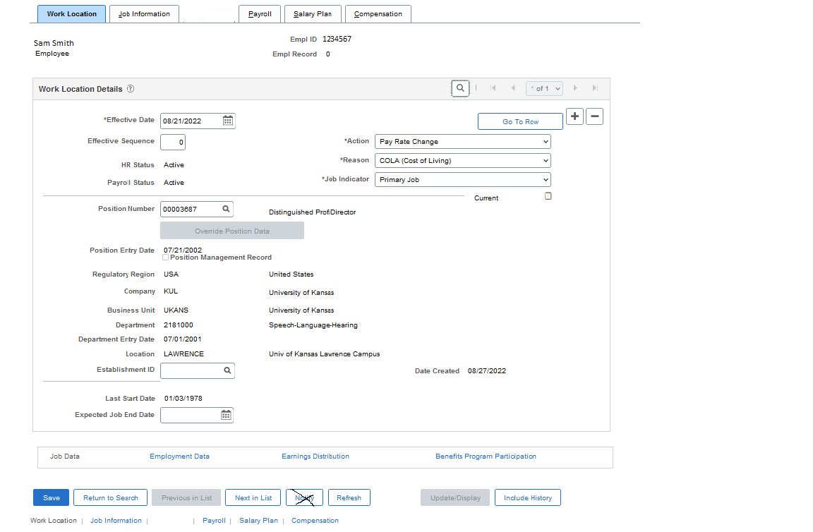
Position & HR Department
Employee Name & ID

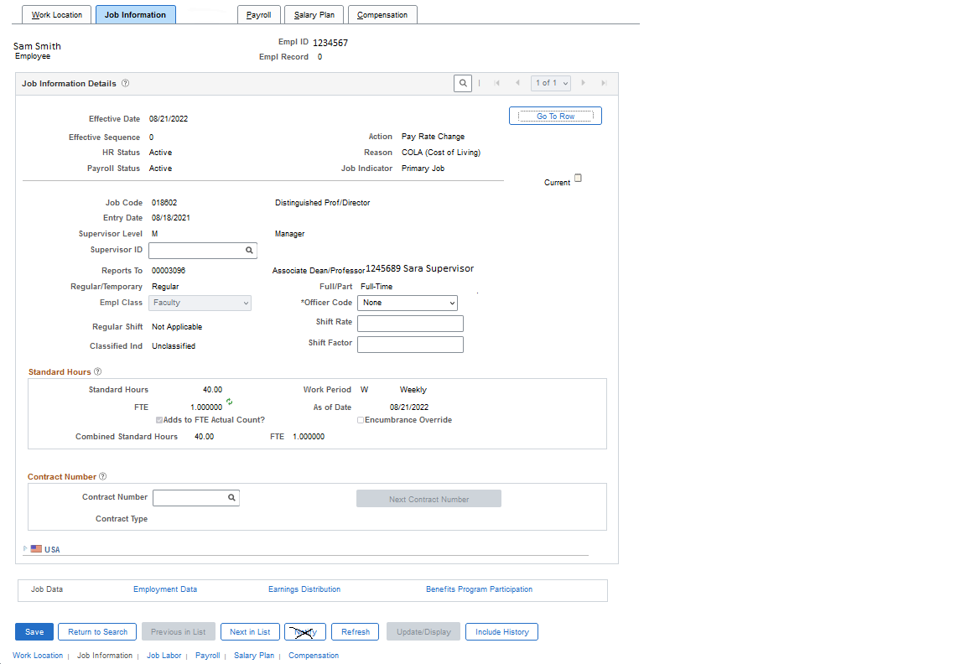
Regular/Temporary
Standard Hour/FTE

HRM Partner Tile>Funding>Combination Code Table
You will use this page to confirm that the funding has an active combo code. If the combo code does not exist, you will use the Funding Setup Request form to submit a request.
The more ChartFields entered, the results are narrowed.
% is also a wildcard or may change to contains on the search parameter or may put in full value
It is recommended that you validate that all combo codes exist and are active before you key in the DBT
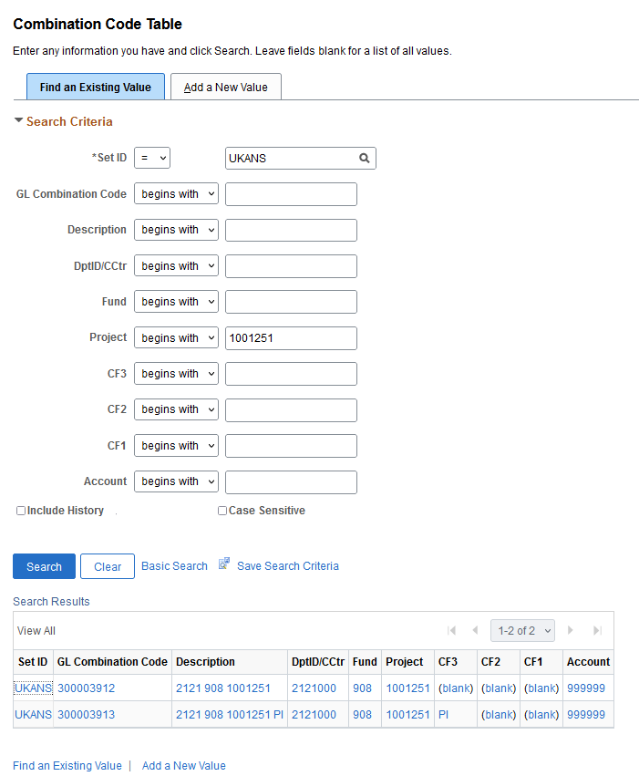
HRM Partner Tile>Funding>Department Budget Table USA
This is the page in which you will key the funding change. Always make sure that you update the effective date. (Remember it will default to the current date so be careful to change it to the appropriate date). After saving the funding on the Dept. Budget Earnings tab, you may check the Debt Budget Deductions tab & Dept. Budget Taxes tab to ensure the funding populated. The caveat to this is if you are doing an override or removing an override. If so, you will need to follow those instructions and validate each of the three tabs.
When searching you may put in full values if using less than full values you may use % as a wildcard or change the operator field (i.e., to contains, begins with)
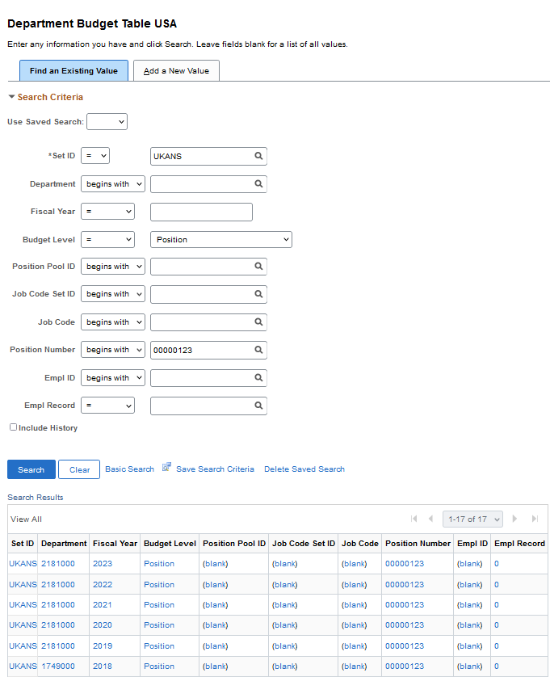
Always check the Fiscal Year and Department (HR)
Search for the position number.
Optional criteria Fiscal Year, Department (HR) or if Pool search, must include Department (HR)

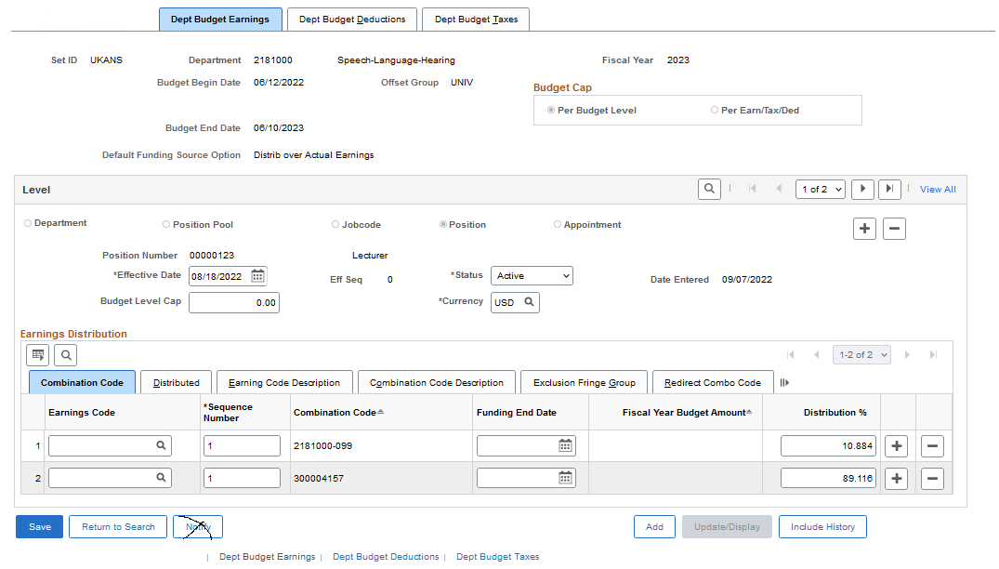
Funding will be entered by the Combination Code Description using the ChartField Details
Delete - existing rows and add + to insert new funding and correct % of distribution
2 Always Update Effective Date
1 (Add Row) +
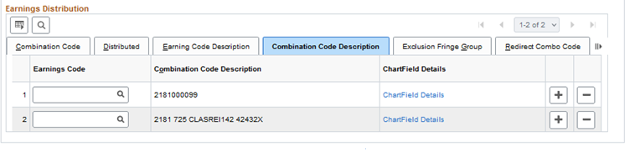
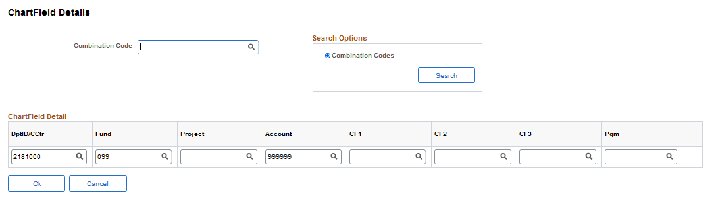
Use the search to find combination codes.

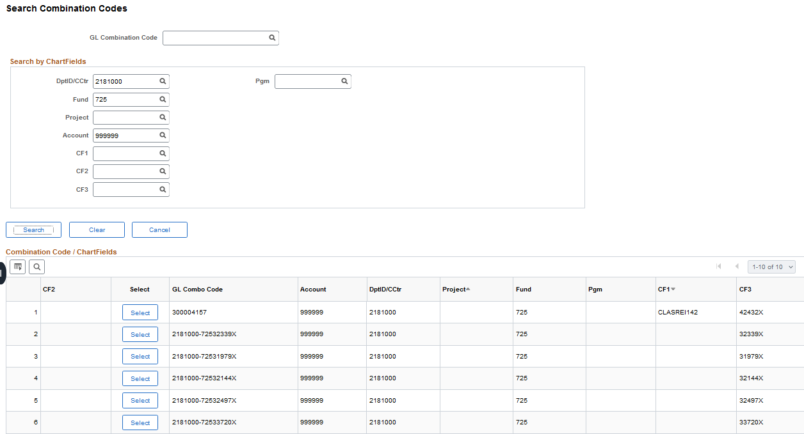
Select the appropriate combo code
Search for the combination code using one or multiple applicable fields.

