Approvals - Manager
Database: https://hr.ku.edu
Tile: KU Approvals Dashboard
Select the KU Approvals Dashboard
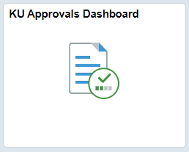
Two tiles will be displayed. Once the University has completed all prior system time (version 9.1) we will be able to have just one tile. Supervisors will need to check both tiles for approvals unless they have completed all actions for employees from the 9.1 version of the system.
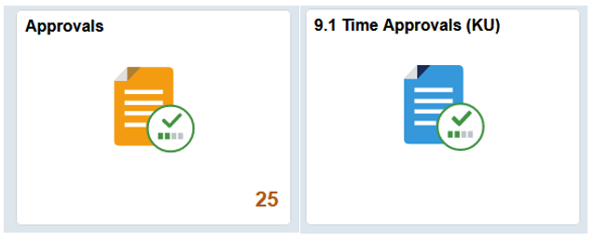
Approvals Tile
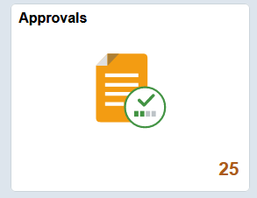
The count of items pending approval will be displayed in the lower right corner of the tile. (This will not include prior version 9.1 time.) Click on Approvals tile.
The types and counts of items to be approved are displayed on the left menu.

Payable Time
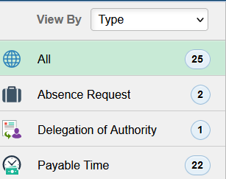
Click on the Payable Time in the list on the left menu displayed.
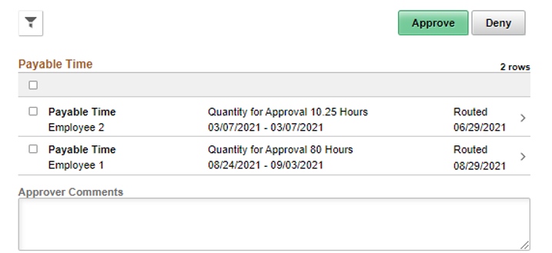
To review the details of the hours and dates before approving, click on the row and the details page will open.
If time on a day is in question, do not Approve or Deny the day in question and do not check the box under Select. Work with the employee to correct the timesheet and let the corrected time reprocess.
Select the checkbox on all the rows that are correct and then click the Approve button.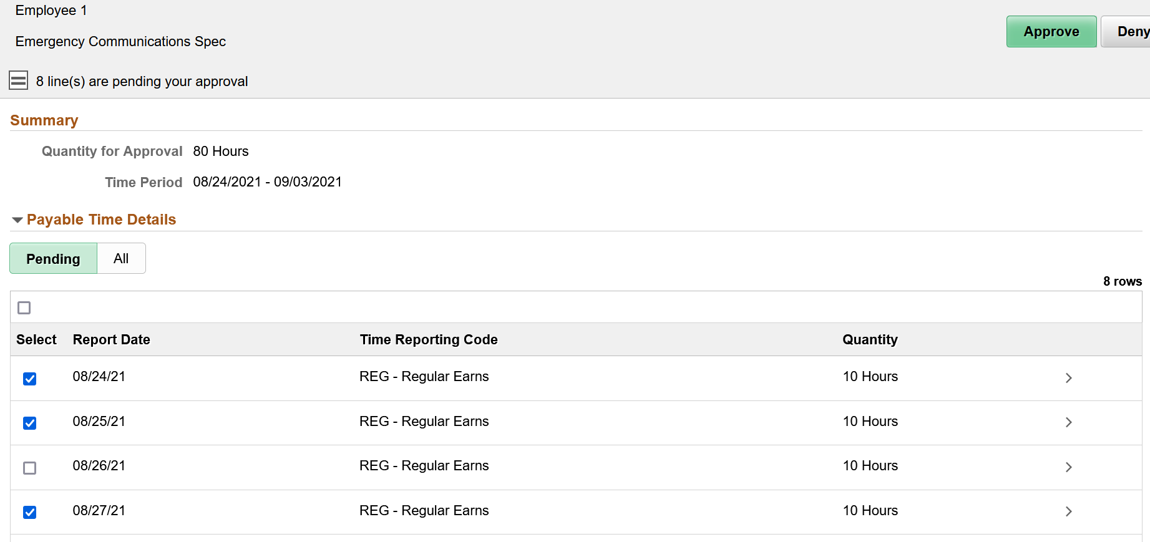
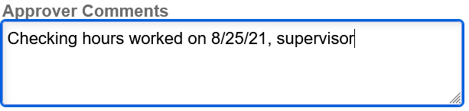
Absence Request
You may use Approve, Deny or Pushback buttons for Absences. Deny and Pushback will send the absence back to the employee. The employee can edit the denied/pushed back absence from the View Request tile. Emails will be sent to the Supervisor when the absence is submitted/resubmitted.
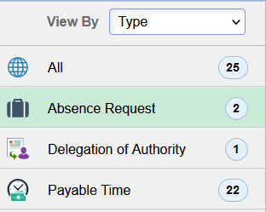
You may select by line, select all or click on the row to open an individual absence row.
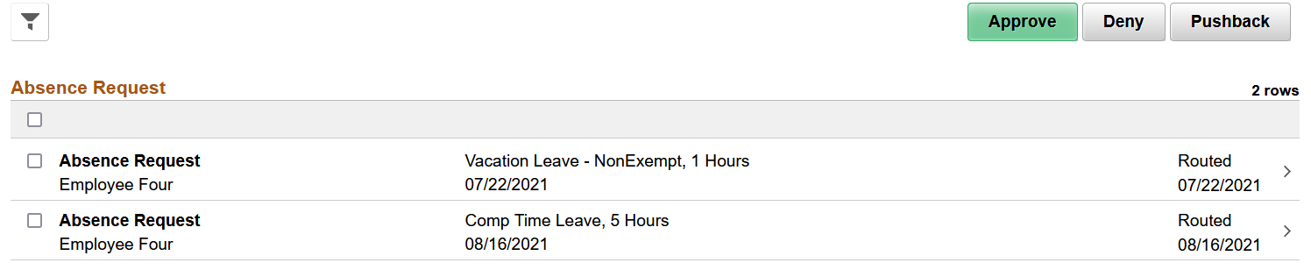
View of an individual absence.
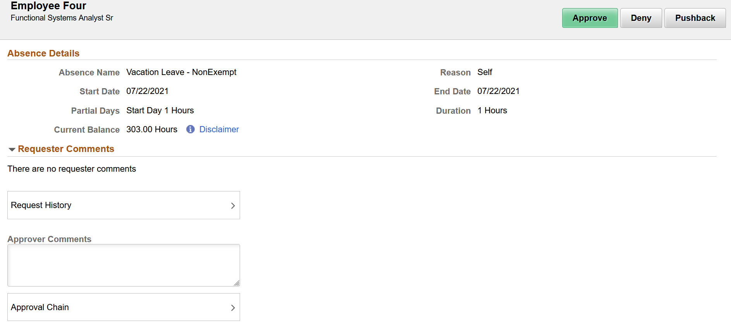

9.1 Time Approvals (KU) Tile
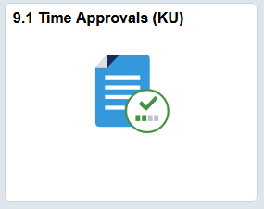
Select the Tile and select the Get Employees button if employee(s) do not display at the bottom of the page.
When all the KU previously entered time in 9.1 has been addressed, this tile will no longer exist. You may not have any prior 9.1 data returned, but it is good to periodically check as time reviewers work on clearing up all pending exceptions and times. This tile will contain both prior system (9.1) processed Time and new system (9.2) processed Time for approval. Once all the prior 9.1 time has been addressed this tile will be removed and we will have the one stop approval tile for all pending items.
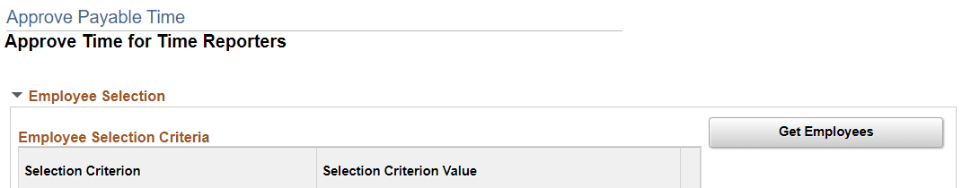
Select individual or multiple employees to approve. If you want to see the detailed hours and days, select the employee’s name and the details will display.
If time on a day is in question, check on for all acceptable days as not to delay pay and click on the Approve button. Do not Approve or Deny the day in question and do not check the box under Select. Work with the employee to correct the timesheet and let the corrected time reprocess. Click on Approve.
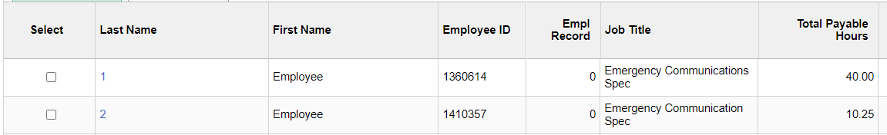
Sign Out securely. Select the 3 horizontal dots on right side of the banner bar and select Sign Out.
