

Absence Management – Employee
Database: https://hr.ku.edu

Tile: Time and Absence
Select the Time and Absence Tile.
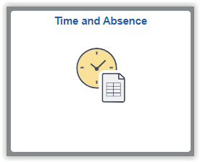
Employees may view their balances (Absence Balances), view and edit absence requests (View Requests), request an absence (Manage Absences), and cancel an approved or submitted absence (Cancel Absences) using the tiles shown below.
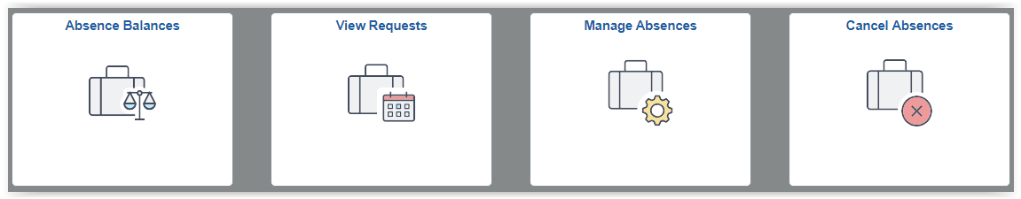

Submit an Absence
- Select the Manage Absences tile. The Manage Absences page displays the following:
  - Top Left: The last three absences requested and a link to view all requests.
  - Top Right Side: Any leave balances as of the last pay period end date.
  - Bottom Right Side: A listing of KU holidays coming up (if eligible for holidays).
  - Middle: Create a new absence request.
- Start Date: Enter first workday of the absence.
- End Date: Enter the last workday of the absence. (Absences will not be paid on days-off or holidays, if eligible.)
- Absence Type: (Grouping of Absences) Select one from drop down.
- Absence Name: (Absence) Select one from drop down.
  - If you are salaried (exempt) and approved for FMLA by HR, select the appropriate FMLA absence.
- Select the Apply Absence button.
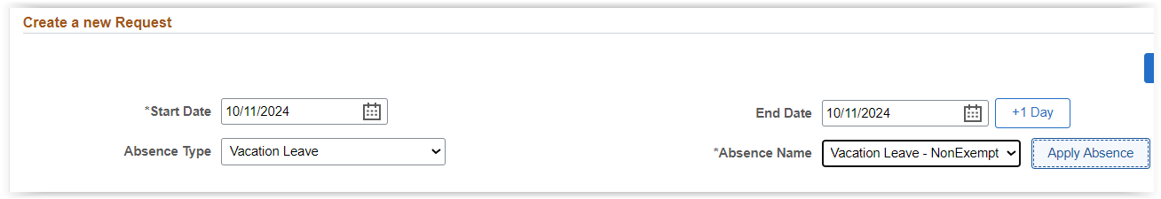
- After selecting the Apply Absence button, additional options are displayed.

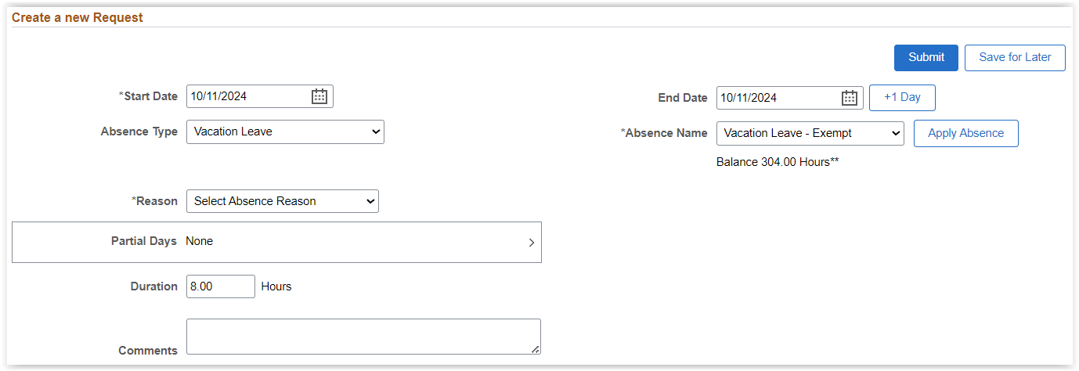
- Reason: Select one, if required.
  - If you are approved for FMLA by HR, select the Reason of FMLA-Family Medical Leave Act.
- Partial Days:
  - For a full day(s) absence, keep the Partial Days option at None, meaning full day(s) absent. (Hours used are from the work schedule).
  - If you will be absent for part of the day(s), use the Partial Days indicators.
    - The Half Day indicator is defaulted on; if you are not taking ½ day, change the indicator to No and key the number of hours absent.
    - Hourly (non-exempt) employees taking less than a full or half day will use the partial days to have the box appear to enter the hours taken. (Leave request are to be submitted in quarter hour increments (.00, .25, .50, .75)
    - Salaried (exempt) employees only use partial days for ½ days, or quarter-hour increments in certain circumstances (i.e., HR approved family medical leave).
Example: Partial Day of a non ½ day partial absence submission. Select Done to close box and return to Absence Request.
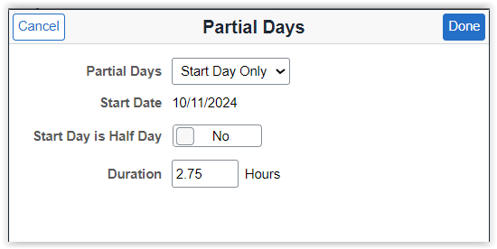
- Duration: Automatically shows a calculation of the total hours or days for your absence when you select the dates and/or if you modify partial days field. These hours/days are calculated from your assigned work schedule in HR/Pay.

- When complete select the Submit button or Save for Later. If saving for later, you will need to edit the absence in the View Requests tile to submit later.
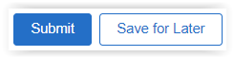

Cancel an Approved or Submitted Absence
- Select Cancel Absence tile.
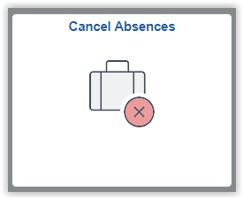

- Absences that are available to cancel will display.
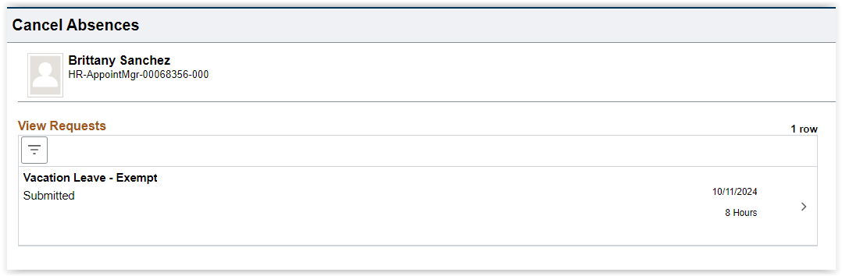
- Select the absence to cancel using the arrow >. A detailed page will open.
- You may add comments.
- Select the Cancel Absence button.
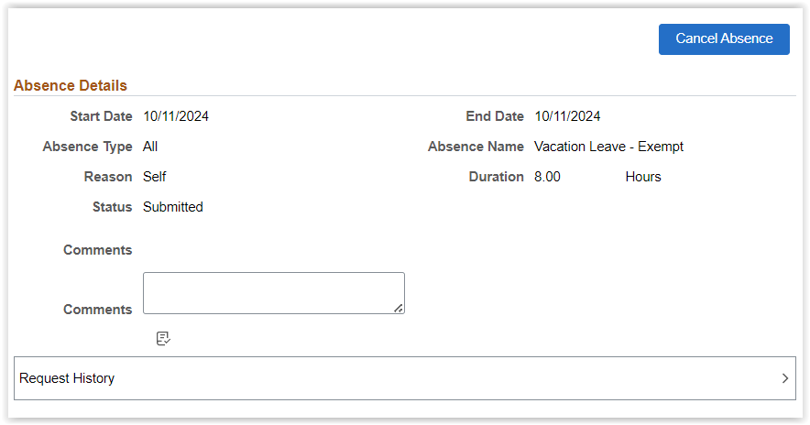

- If the absence was previously approved, an email will be sent to the supervisor and the Cancel Absence Request will display in their Approvals tile.
  - The supervisor will need to approve the Cancel Absence Request for the absence to be cancelled.
  - After the cancelled absence is approved, the employee can edit and resubmit using the View Requests tile.

- If the absence was not previously approved, the absence will be cancelled upon submitting the Cancel Absence and will be available to edit and resubmit in the View Request tile.

Resubmit a Cancelled Absence (Edit an Absence)
- Select View Requests tile.
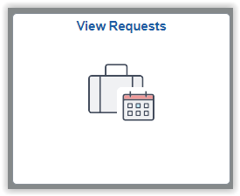

- Absences are displayed.
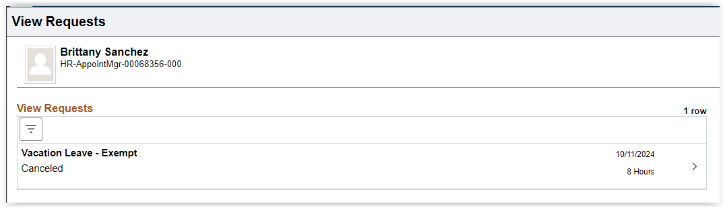
- Select the canceled or saved for later or pushed back or denied absence to modify it. A detailed page will open.
- Change the options as needed.
  - If the Absence Type and Absence Name are changed, the Apply Absence button will need to be selected again.
- After all changes are completed, select the Submit button.

Compensatory Time Payouts
- Start Date: Today or Future Date
  - Only one payout per type is to be requested in a payroll period.
- End Date: Same date as Start Date.
- Absence Type: Select “Payouts - Comp or Holiday Comp”
- Absence Name: Select “Payout Comp Time” or “Payout Holiday Comp Time”
- Select the Apply Absence button.
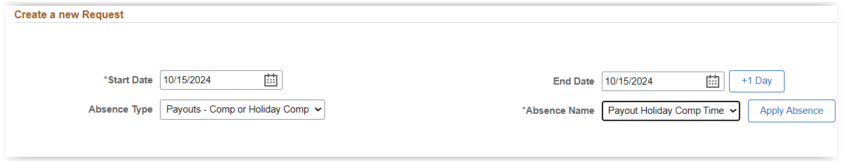

- After selecting Apply Absence button, additional options appear.

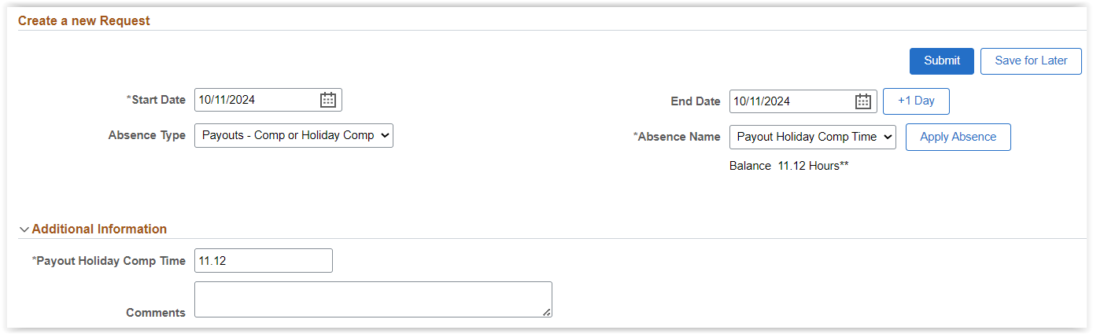
- Additional Information - Payout Comp Time or Payout Holiday Comp Time: Enter the total hours to be paid.
  - The hours entered cannot exceed the balance displayed under the Balance Information.
- Select Submit button.
  - The hours displayed for Payouts will not display accurately on the timesheet. Please review the View Requests tile for confirmation of the actual hours submitted.

Employee Guidelines
- Absences can only begin or end on a date the employee is scheduled to work.
- Employees may not request the same Absence Name more than once on the same day (i.e., 2 sick leaves for same date).
- HR/Pay will calculate the hours correctly, considering non-working days such as weekends and holidays, using the work schedule that is assigned to the employee.
- To be paid correctly, the absence should be submitted by the end of each week in which the leave was taken to allow the supervisor time to approve. Supervisors will receive an email upon submission.
- Employees will receive an email when the request has been approved.
- Employees may view the status of absence using View Requests tile.
- Employees may edit a saved, pushed back, denied, or cancelled absence in the View Requests tile.
- Compensatory Time:
  - will be paid out by the system once it exceeds the maximum (generally 90 hours),
  - will be paid out by the system if the employee changed departments,
  - will be paid out by the system if the employee changes from hourly (non-exempt) to salaried (exempt),
  - and is not available to be used or paid until the payroll period after it is earned.
- Compensatory Time and Holiday Compensatory time is paid out by the system upon termination from the University.
- Leave and holiday information can be found at humanresources.ku.edu/leave-holidays.
- Balances are as of the end of the prior payroll period.

Sign Out securely. Select the 3 vertical dots on right side of top banner and select Sign Out.
