Elapsed Timesheet Reporting
Database: https://hr.ku.edu
Tile: Time and Absence>Report Time or Enter Time
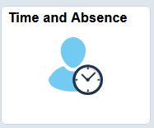
- This document applies only to hourly (non-exempt) employees who are assigned and responsible for using a timesheet to report total hours per day.
- Assigned employees are responsible for reporting actual hours worked on the day worked.
  - All hours are required to be recorded/tracked in the University’s HR/Pay system. This is a condition of employment.
- Employees must report their time by the end of their work week at a minimum.
  - More frequent reporting may be designated by the supervisor or employee choice.
- Time is to be reported in .25 increments. Consult the Time Rounding Chart if needed.
- Two tiles are available.
  - Report Time tile is reporting by day and will work on any device.
  - Enter Time tile allows you to report a week at a time and is for large screen devices.
- If you hold multiple jobs, you will need to select the correct job from the drop down and select Apply before recording your time.
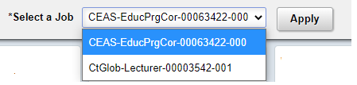

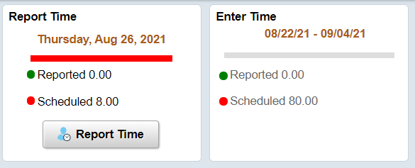

Report Time
- Click on the Report Time button.
- Page will default to today, click on the previous or next arrows, or date header to choose a different date.
- Choose the appropriate Time Reporting Code.
- Key total hours for the day for the Time Reporting Code selected.
- Select the Submit button.
- If you need to report multiple Time Reporting Codes, repeat the process. Each entry will need to be submitted separately.
- This is the only method that works with small devices.
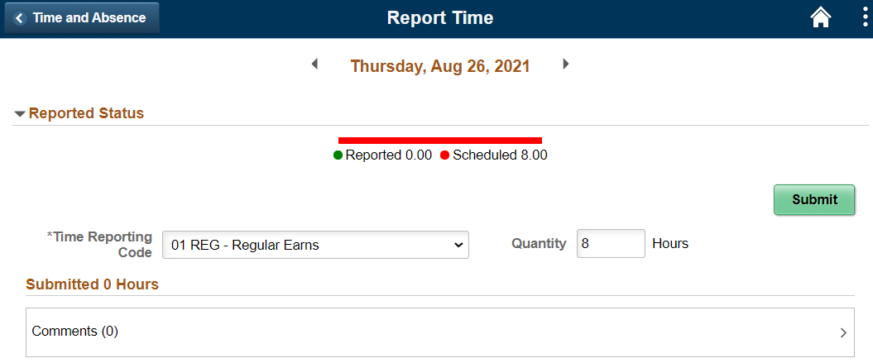

Enter Time
- Click on the Enter Time button.
- Choose the appropriate Time Reporting Code.
- Key total hours for the day for the Time Reporting Code selected.
- If multiple Time Reporting Codes are needed use the + (plus) to add a row. The – (minus) removes the row.
  - If a holiday is on the timesheet or an absence is displayed etc., you may need to add a row to enter time.
- Select the Submit button.
  - The screen shot is split into 2 rows.
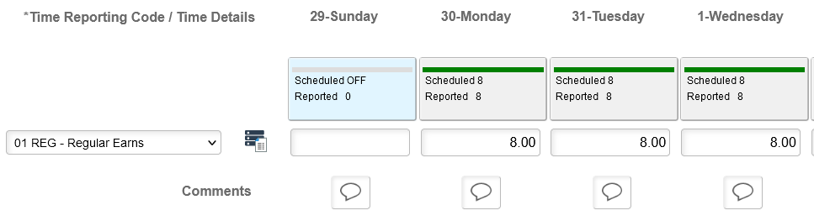
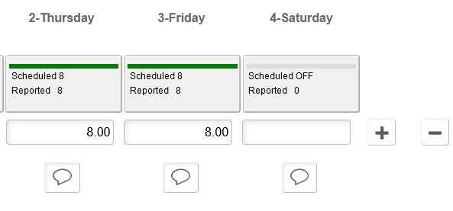

Sign Out securely. Select 3 dots on right side of banner bar and select Sign Out. 