KU Payroll Dashboard
Database: https://hr.ku.edu
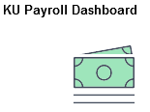
This tile contains information regarding paycheck, direct deposit, W4 and other payroll related information.
Paychecks
Paychecks are generally available 5 days prior to pay date.
- Select Check Date by opening with click.
- If the paycheck does not open in pdf, please reference IT Knowledge Base link
IT Document or contact IT Customer Service at 864-8080 or itcsc@ku.edu .

In these examples the amounts have been removed along with other personal identifiable data.

- Your 11-character State Employee ID can be found here under SOKS ID.

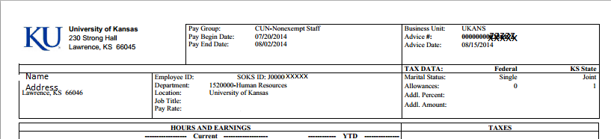

Payroll Site which contains the Pay Period and Pay Date Calendars: payroll.ku.edu

Abbreviations used in deduction codes:

AT | After Tax
BT | Before Tax
DISC | Discount
EE | Employee
ER | Employer (KU)
FSA | Flexible Spending Account
HRA | Health Reimbursement Account
HSA | Health Savings Account
HRA | Health Reimbursement Account
Direct Deposit Classic
Employees are required by Kansas Statute to have their pay distributed by Direct Deposit (Electronic Funds Transfer-EFT).

Employees may have one to multiple accounts and may choose by percentage or set amount with remaining balance option.

To modify you will need your existing account as a security measure.
If only one account is entered, select Balance as the Deposit Type. The system will default as 999 for Deposit Order.

W4 Tax Withholding Classic
Federal form

State forms are available by contacting the Payroll Office payroll@ku.edu

State of Kansas W-2
Provides link to information obtaining the data from the State of Kansas SHaRP system.

